Shujaa SMS Gateway Administrator Guide

A Product of Shujaa Solutions Limited

2013

www.shujaa.co.ke

http://shujaa.mobi

info@shujaa.co.ke

2013



INFORMATION IN THIS DOCUMENT IS PROVIDED IN CONNECTION WITH SHUJAA SOLUTIONS’ PRODUCTS. NO INTELLECTUAL PROPERTY RIGHTS, LICENSE, EXPRESS OR IMPLIED, BY ESTOPPEL OR OTHERWISE, IS GRANTED BY THIS DOCUMENT, EXCEPT AS PROVIDED IN SHUJAA SOLUTIONS’ TERMS AND CONDITIONS OF SALE FOR SUCH PRODUCTS. SHUJAA SOLUTIONS ASSUMES NO LIABILITY WHATSOEVER, AND SHUJAA SOLUTIONS DISCLAIMS ANY EXPRESS OR IMPLIED WARRANTY, RELATING TO SALE AND/OR USE OF SHUJAA SOLUTIONS’ PRODUCTS INCLUDING LIABILITY OR WARRANTIES RELATING TO FITNESS FOR A PARTICULAR PURPOSE, MERCHANTABILITY, OR INFRINGEMENT OF ANY PATENT, COPYRIGHT OR OTHER INTELLECTUAL PROPERTY RIGHT.

The Programs (which include both the software and documentation) contain proprietary information; they are provided under a license agreement containing restrictions on use and disclosure and are also protected by copyright, patent, and other intellectual and industrial property laws. Reverse engineering, disassembly, or decompilation of the Programs, except to the extent required to obtain interoperability with other independently created software or as specified by law, is prohibited.

The Programs are not intended for use in any nuclear, aviation, mass transit, medical, or other inherently dangerous applications. It shall be the licensee's responsibility to take all appropriate fail-safe, backup, redundancy and other measures to ensure the safe use of such applications if the Programs are used for such purposes, and we disclaim liability for any damages caused by such use of the Programs.

Shujaa Solutions may make changes to specifications and product descriptions at any time, without notice.

No part of this publication may be reproduced, transmitted, transcribed, stored in a retrieval system, or translated into any language or computer language, in any form or by any means, electronic mechanical, magnetic, optical, chemical, manual, or otherwise, without the prior written permission of Shujaa Solutions Ltd.

Copyright © 2013 by Shujaa Solutions Ltd. All rights reserved.

All other trademarks are property of their respective owners.

Shujaa Solutions Ltd.

InTrade Africa Place, Kauria Close

Off Muthangari Road, Lavington

P.O. Box 48183 – 00100

Nairobi, Kenya

Table of Contents

1. Preface 2

1.1. Document Conventions 2

1.2. Related Documents 2

2. Introduction 3

3. Installation 3

3.1. System Requirements 4

3.2. Installation Procedure 4

3.3. Configuration & Tuning 4

4. System Administration 4

5. Maintenance 5

5.1. Backup & Restoration 5

5.2. Log File Management 5

5.3. Application of System Updates 5

6. Monitoring 5

7. Troubleshooting 5

8. Appendices 5

A. Glossary 5

B. References 6

# 1. Preface

## 1.1. Document Conventions

## 1.2. Related Documents

# 2. Introduction

About the software, including some pictures/illustrations

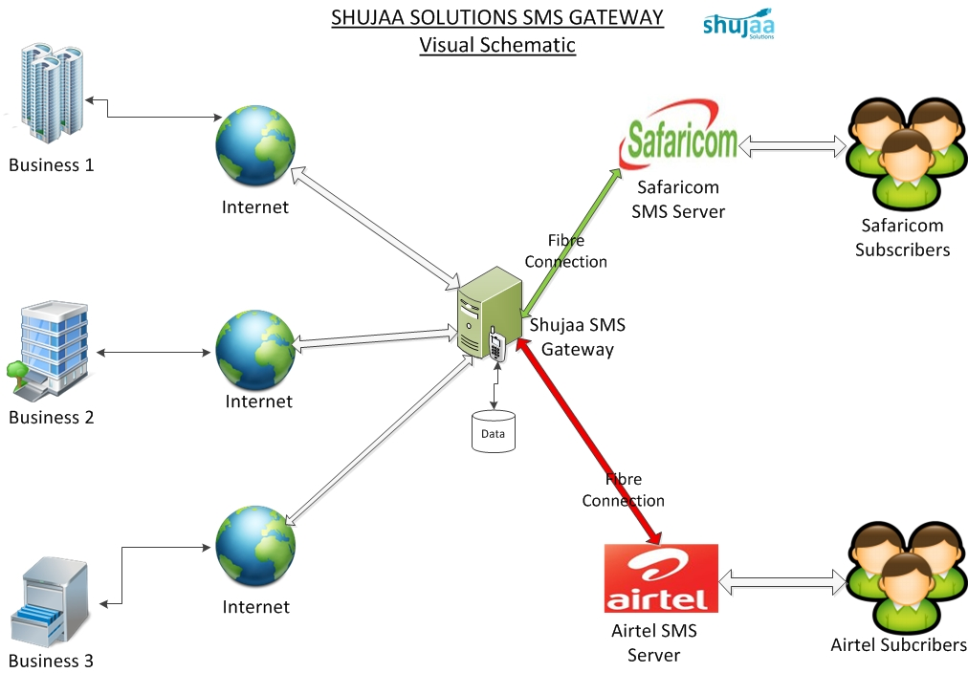

Figure 2.1: Shujaa SMS Gateway Overview

# 3. Installation

## 3.1. System Requirements

Hardware, Operating System, Application Server, Network, RDBMS, etc

## 3.2. Installation Procedure

Step-by-step guide of how to install software, including screen shorts if necessary.

## 3.3. Configuration & Tuning

Examples include configuring network ports, emails that will receive reports etc

# 4. System Administration

All the things that one can do as an Administrator of the system are to be documented here. These include screen shots where appropriate.

# 5. Maintenance

Routine maintenance tasks. Examples include:

## 5.1. Backup & Restoration

## 5.2. Log File Management

## 5.3. Application of System Updates

# 6. Monitoring

How to view system performance, for example how to generate reports, view log files etc.

# 7. Troubleshooting

Basic guide on how to fix commonly occurring system errors.

# 8. Appendices

## A. Glossary

|  |  |
| --- | --- |
| API …………………………………………… | Application Programmer Interface |
| CCK ………………………………………….. | Communications Commission of Kenya |
| HTTP ………………………………………... | Hyper Text Transfer Protocol |
| J2EE ……................................................... | Java 2 Enterprise Edition |
| MO …………………………………………... | Mobile Originated SMS |
| MSISDN …………………………………… | A number uniquely identifying a subscription in a GSM mobile network |
| MT …………………………………………… | Mobile Terminated SMS |
| PRSP ………………………………………… | Premium Rate Services Provider |
| SLA …………………………………………. | Service Level Agreement |

## B. References

Books, journals, course materials or websites where literature is found.

This is how you reference a book:

Author, A. A., Author, B. B. & Author, C. C. (year of publication). *Title of book: Subtitle*. (Edition [if not first]). Place of publication: Publisher.

For example:

Book with one author:

Adair, J. (1988) *Effective time management: How to save time and spend it wisely*, London: Pan Books.

Book with two authors:

McCarthy, P. and Hatcher, C. (1996) *Speaking persuasively: Making the most of your presentations*, Sydney: Allen and Unwin.

